BSDS FINAL PROJECT

NavEd (Smart Campus Navigation & Student Assistance System)



Project Advisor

Syed Atir Raza Shirazi

Presented by:
Group ID: S25DS002

Student Reg# Student Name
L1F21BSDS0045 | MUHAMMAD RASIKH JAVED
L1F21BSDS0042 | ZUHAIB IRFAN
L1F21BSDS0026 | MUHAMMAD ASAD JAMSHAD
Faculty of Information Technology & Computer Science

University of Central Punjab

Complete System

SDP Phase IV
NavEd (Smart Campus Navigation & Student Assistance System)
Advisor: Syed Atir Raza Shirazi
Group S25DS002
Member Name | Primary Responsibility
M. Rasikh Javed | Equal Responsibilities
M. Asad Jamshad | Equal Responsibilities
Zuhaib Irfan | Equal Responsibilities

Table of Contents
Table of Contents i
Revision History ii
Previous Phases Feedback ii
Abstract iii
1. Introduction 1
1.1 Product 1
1.2 Background 1
1.3 Objective(s)/Aim(s)/Target(s) 1
1.4 Scope 1
1.5 Business Goals 1
1.6 Document Conventions 1
1.7 Miscellaneous 1
2. Technical Architecture 2
2.1 Application and Data Architecture 2
2.2 Component Interactions and Collaborations 2
2.3 Design Reuse and Design Patterns 3
2.4 Technology Architecture 3
2.5 Architecture Evaluation 3
3. Detailed/Component Design 4
3.1 Component-Component Interface 4
3.2 Component-External Entities Interface 4
3.3 Component-Human Interface 4
4. Screenshots/Prototype 4
4.1 Workflow 4
4.2 Screens 4
4.3 Additional Information 4
5. Other Design Details 5
6. Test Specification and Results 5
6.1 Test Case Specification 5
6.2 Summary of Test Results 6
7. Project Completion Status 6
8. Deployment/Installation Guide 7
9. User Manual 7
10. References 7
11. Project Summary Form 8
Appendix A: Glossary 11
Appendix B: IV & V Report 12

Revision History
Name | Date | Reason For Changes | Version

Previous Phases Feedback

Idea Defence Feedback (Screenshot)

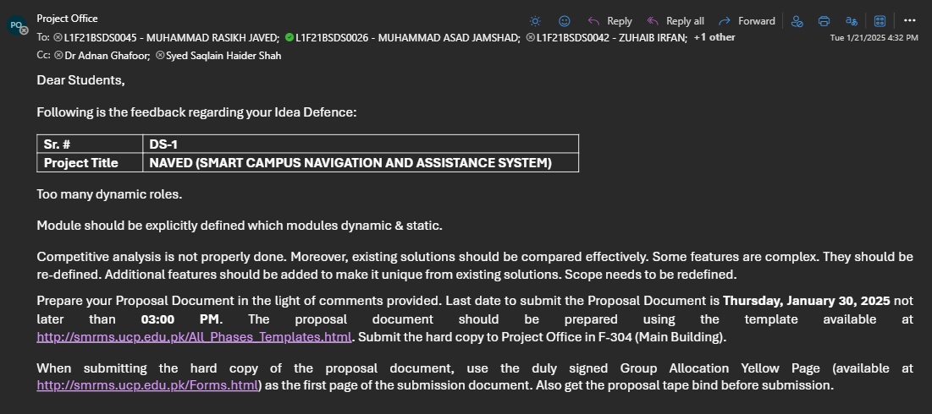

Phase 2 (SDS) Feedback (Screenshot)
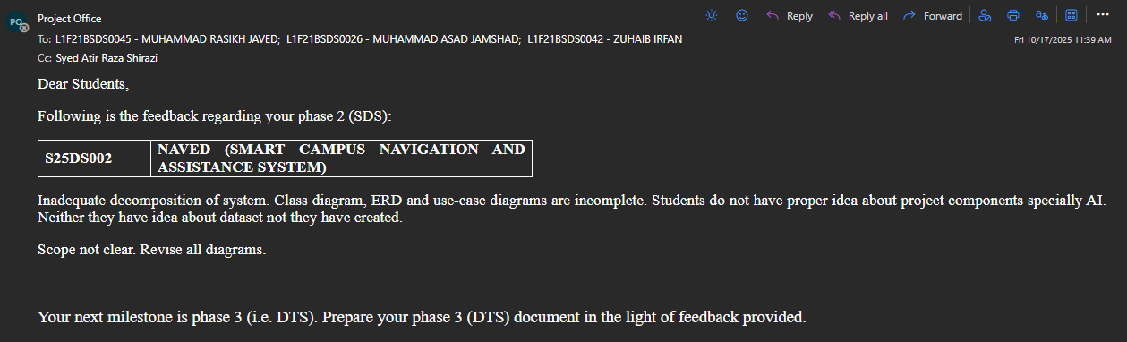

Abstract
NavEd is a smart, AI-powered navigation and campus assistance system designed to transform the traditional university experience into a seamless, intelligent, and accessible environment. The system integrates multiple advanced technologies, including a 3D model-based navigation module, real-time parking assistance, and an AI-driven academic assistant chatbot.
NavEd aims to solve common problems faced by students, faculty, and visitors on large campuses such as difficulty in locating buildings, managing parking, making academic study plans. Through the use of artificial intelligence, real-time data processing, and user-centric design, the system enhances usability, promotes engagement, and ensures inclusivity via accessibility features.
The project draws on interdisciplinary knowledge areas including AI, computer vision, software engineering, and user experience design. The outcome is expected to be a robust, scalable solution that can be customized for deployment across various educational institutions, setting a new standard for smart campus systems.

Introduction
In today’s fast-paced academic environment, students face numerous challenges in managing their time, staying organized, and navigating the complexities of campus life. With campuses becoming increasingly larger and more dynamic, students often struggle to find efficient ways to get from one location to another, and manage academic tasks. To address these challenges, we introduce “NavEd” .
NavEd combines cutting-edge technologies in Data Science, Artificial Intelligence, and Real-Time Analytics to offer a smart, user-friendly solution for campus navigation, and academic management. Whether it’s finding the quickest route to a class, making study plans, or locating a vehicle in a crowded parking lot, NavEd centralizes all these functionalities in a single platform. Navigating large campuses, finding parking, and managing academic tasks are daily challenges for students and faculty. NavEd is an AI-powered mobile application designed to transform this experience into a seamless, intelligent, and accessible journey.
1.1 Product
NavEd is a smart campus ecosystem designed to streamline the university experience through an
integrated suite of AI-driven tools. The platform features an AI-Powered Navigation system that
delivers real-time, step-by-step guidance via an intelligent bot with both text and voice support. This is complemented by a Smart Parking System, which offers a visual dashboard where users can check availability through a color-coded interface and update their parking status manually. Additionally, NavEd includes a RAG AI Study Assistant that provides personalized academic support by analyzing user-uploaded study materials to generate tailored content, quizzes, and study plans. To ensure broad accessibility, the system incorporates comprehensive features such as voice guidance, high-contrast modes, and adjustable interfaces, making campus navigation and academic management inclusive and efficient for all users.

Background
With the rapid advancement of digital technologies, smart campus solutions have emerged as a global trend aimed at enhancing operational efficiency and user experience within academic institutions. While many universities have adopted standalone systems for functions such as library management, student communication, or navigation, these solutions often operate in isolation, resulting in fragmented user experiences. Existing campus solutions often operate in isolation, leading to a fragmented user experience. NavEd addresses this gap by offering a unified, intelligent platform that combines real-time navigation, parking management, and AI-driven academic support into a single, cost-effective application tailored for modern universities.

Objective(s)/Aim(s)/Target(s)

The specific objectives of the project are as follows:
  - Develop a 3D Campus Navigation System:
Create an intelligent navigation system using Wide-Angle HD Video analysis and computer vision for real-time positioning and dynamic pathfinding. Implement an AI-powered conversational bot that provides multimodal guidance (text and voice-based) from point A to B within the campus environment. The system will leverage real-time video feed processing to detect obstacles, identify landmarks, and provide adaptive routing based on current campus conditions. Additional features include indoor-outdoor wayfinding integration, crowd density analysis for optimal route selection, and predictive navigation based on class schedules and campus events.
  - Implement Smart Parking Guidance System:
Develop an intuitive visual parking dashboard with comprehensive parking floor maps featuring rectangular spot indicators and real-time color-coded availability status (Green: Available, Red: Occupied). Create a robust user-prompted check-in/check-out system where users manually update their parking status through the mobile application, with immediate database updates triggered by user actions. The system will incorporate parking session tracking, time-based analytics, reservation capabilities for special needs parking, and integration with campus parking regulations and fee structures where applicable.

  - Provide RAG-Based AI Study Assistant:
Design and implement a sophisticated Retrieval-Augmented Generation (RAG) system with advanced LLM API integration for enhanced contextual understanding and response generation. Enable students and faculty to upload diverse study materials (PDFs, documents, notes, presentations) through a secure document management system. For students, provide personalized study plan generation based on uploaded materials, content-specific Q&A with citation tracking, progress monitoring with performance analytics, and adaptive learning path recommendations. For faculty, offer automated quiz generation from course materials, assignment creation tools with customizable difficulty levels, assessment analytics, and plagiarism detection capabilities.

  - Incorporate Comprehensive Accessibility Features:
Ensure full inclusivity by implementing extensive accessibility features including voice-guided navigation with multiple language support, high-contrast modes with customizable color schemes, adjustable text sizes with dynamic layout adaptation, and screen reader compatibility meeting WCAG 2.1 AA standards. Additional accessibility implementations include haptic feedback for navigation alerts, gesture-based controls for motor-impaired users, audio descriptions for visual elements, and simplified navigation modes for cognitive accessibility. The system will also feature emergency assistance integration, real-time captioning for audio guidance, and customizable interface layouts to accommodate diverse user needs and preferences.

  - Ensure System Scalability and Cross-Platform Compatibility:
Develop a scalable architecture capable of supporting multiple campus deployments with customizable mapping and navigation data. Implement cross-platform compatibility ensuring seamless user experience across iOS and Android mobile devices, with responsive web interfaces for administrative functions. The system will feature cloud-based data synchronization, offline functionality for essential navigation features, and robust API integrations with existing university systems including student information systems, library databases, and emergency notification systems.
  - Implement Advanced Analytics and Reporting Capabilities:
Incorporate comprehensive analytics modules for tracking system usage patterns, navigation efficiency metrics, parking utilization statistics, and academic performance correlations. Provide administrators with detailed reporting dashboards for campus traffic analysis, resource allocation optimization, and strategic planning insights.

1.4 Scope
The business goals of this project include:
- Streamlined Campus Operations
Enhance operational efficiency through a unified digital campus platform that integrates navigation, parking, and academic services.
- Optimized Resource Utilization
Reduce time spent by students and staff in locating buildings, vehicles, and campus resources, thereby improving daily productivity.
- Enhanced Student Engagement and Success
Promote student engagement and academic success with AI-powered collaboration and personalized study tools.
- Scalable and Market-Ready Solution
Ensure the platform's architecture is scalable for easy deployment and customization across multiple educational institutions.
- Sustainable Revenue Model
Enable future monetization and project sustainability through institutional licensing and premium feature offerings.

Document Conventions
- Headings: Bold, Size 14, Times New Roman.
- Subheadings: Bold, Size 12, Times New Roman.
- Body Text: Regular, Size 12, Times New Roman.

Font Style and Size
- Headings: Bold, Size 18, Times New Roman.
- Subheadings: Bold, Size 16, Times New Roman.
- Body Text: Regular, Size 12, Times New Roman.
Highlighting
- Technical terms are capitalized where appropriate (e.g., LPR, AI).
- Numbered and bulleted lists are used for readability.
Numbering: Sections and their subsections are numbered hierarchically (such as 1, 1.1, 1.1.1)
Tables and Figures: Titled above and explained below.

Technical Architecture
NavEd is a custom-built, AI-powered smart campus system that integrates real-time navigation, parking management, academic assistance, and library services into a unified platform. The system employs a layered microservices architecture with the following processing capabilities:
- Real-time Processing: Live navigation updates, parking availability, and AI chat responses
- Batch Processing: Daily analytics, study plan generation, and data synchronization
- Transaction Processing: User authentication, booking reservations, payment transactions
- Analytical Reporting: User behaviour analysis, campus traffic patterns, system performance metrics

Application and Data Architecture
Major Application Components:
- Mobile Application Layer: Flutter-based cross-platform app with role-based interfaces for Students, Faculty, and Visitors
- API Gateway Layer: Django REST Framework handling request routing, rate limiting, and authentication
- Business Logic Layer:
  - Navigation Service (A* algorithm implementation with real-time rerouting)
  - Parking Management Service (IoT sensor integration + LPR processing)
  - AI Assistant Service (NLP/LLM integration for study plans and chatbot)
  - Library Integration Service (REST API connectors to university systems)
  - User Management Service (OAuth 2.0 with role-based permissions)

Data Architecture Status (70% Complete):
- PostgreSQL Database: Core schema implemented with Users, Locations, Parking, Courses, and Books tables
- Firebase Realtime Database: Live notifications and session management operational

- Redis Cache: Session storage and frequent query caching active
- AWS S3: Map assets and user profile images storage configured

Component Interactions and Collaborations
<Provide interactions and collaborations between your system components/processing units. Diagrams/Tools that may be provided in this section include Design Level Sequence Diagram, Collaboration Diagram, Event Traces, Detailed DFD, Activity Diagram etc. All these diagrams should have more details than the details provided in Phase 1 of the SDP. Describe each diagram briefly.>

Design Reuse and Design Patterns
<State any reuse during development of the system>

Technology Architecture
<Describe the infrastructure required to support the application and information architecture. Give complete details of the technology architecture. In this section provide details regarding platform, system hosting, connectivity requirements, modes of operations etc.>

Architecture Evaluation
<Describe the reason(s) behind the decision related to selection of infrastructure/technology used. Discuss pros and cons of the selected technology/infrastructure and the alternative technology/infrastructure. For example why have your group selected a particular API from a list of APIs? Why have your group preferred a particular framework over an alternative framework.>

Detailed/Component Design
<In this section provide details of the types of interactions and collaborations required in your project. Also elaborate the interactions already described in section 2.2. Tools such as deployment diagram, class diagram (complete in all aspects), database schema, design level sequence diagram, state diagram, petrinets etc. may be used to provide all the details. Any design principles being followed during the projects may be mentioned and described in this section.>

Component-Component Interface
<Describe how do the components of your system interact. Sequence diagram, collaboration diagrams may help>

Component-External Entities Interface
< Express the communication between components of your system and components of other systems such as NADRA system, bank, credit card verification system, third party multi game server etc. Use appropriate diagram to show the interaction in a better manner.>

Component-Human Interface
< Provide the list of screens/points that receive/provide input/output from/to user. Describe any HCI related norms followed in your project. Further details regarding the interface may be provided in the next section>

Screenshots/Prototype
<This complete section should be an improved version of the section presented in previous phase>

Workflow
<Describe complete workflow of your system. Swim-lane diagram may be used. This section should be an improved version of the section presented in previous phase>

Screens
< Include all screenshots of your complete software application’s graphical user interface.>

Additional Information
<Any additional information>

Other Design Details
<Describe all design details not covered in previous sections. Add subsections as required. There can be details regarding Research Oriented, Game Oriented, or Hardware based projects that have not been covered in this document before, those details can be provided in this section. For example research based projects may use this section to present their results and analysis; hardware based projects may use this section to describe interface dependencies and issues etc.>

Test Specification and Results

Test Case Specification
< Fill out the following template for each test case, also add any additional test cases that were not part of Phase 3 document. Provide separate tables for input data with each test case if applicable. Research based projects may need to replace this test specification with their own test mechanism.>

Table 6.1: TC-1
Identifier | TC-1
Related requirements(s) | <Include use-case identifier(s) for functional requirement(s) and SRS section/sub-section number(s) for other requirement(s).>
Short description | …
Pre-condition(s) | …
Input data | …
Detailed steps | …
Expected result(s) | …
Post-condition(s) | …
Actual result(s)
Test Case Result

Summary of Test Results
<Provide in tabular form the defects found in each of your software modules. For example see Table 6.2 below.>

Table 6.2: Summary of All Test Results
Module Name | Test cases run | Number of defects found | Number of defects corrected so far | Number of defects still need to be corrected
Module 1 (for example Bill Calculation Module, Speech Processing Unit | TC1, TC2,…
Module 2 | …
Module 3 | …
… | …
 | …
 | …
 | …
Complete System | <Sum all of the above> | <Sum all of the above> | <Sum all of the above> | <Sum all of the above>

Project Completion Status
<Show your progress and provide current status of the project in accordance with the plan provided in project proposal and/or the previous phase. Provide list of modules that have been completed and the modules that could not be completed. Also provide a list of modules that have been implemented but were not part of original requirements (additional work). Use table 7.1 for this purpose.>
Table 7.1: Project Completion Status
Module Name | Status  (Complete, Partially Implemented, Not Implemented)
Module 1 (for example Bill Calculation Module, Speech Processing Unit
Module 2 | …
Module 3 | …
Complete System | …

<Also add a table to show how many of the objectives/targets (mentioned in section 1.3) have been met? And to what extent have they been met (whether an objective has not been met, or has been met partially or fully). Also state the reason if an objective has not been met or has been partially met. For example see table 7.2>
Table 7.2: Objective(s)/Target(s) Status
Target/Objective | Status  (Completed,  Partially Completed,  Not Completed) | Reason(s)
Objective 1
Objective 2 | …
… | …
Number of Targets Completed | …
Number of Targets Partially Completed
Number of Targets Not Completed

Deployment/Installation Guide
<Provide a list of instructions such that users of your system can deploy and install your system on their own>

User Manual
<Provide a manual such that users of your system can use your system after installation>

References
<List all books, conference papers, journal articles, websites, etc. used in preparing the content of this document. Provide enough information so that the reader could access a copy of each reference, including title, author, volume/edition number, page number(s), and publication year. Mention complete URLs for websites.>

Project Summary Form
Name of Project | Click or tap here to enter text.
Project Type | Choose an item.
Department | Choose an item.
Start Date | Click or tap to enter a date.
Completion Date | Click or tap to enter a date.
Supervisor / Team Leader | Click or tap here to enter text.
Team Members (if any) | Click or tap here to enter text.
Funding Agency (if any) | Click or tap here to enter text.
Amount of Funding (if any) | Click or tap here to enter text.
Assign SDGs to Project | Choose an item.
Motivation of Project | Click or tap here to enter text.
Practical / Potential Application | Click or tap here to enter text.
Abstract | Click or tap here to enter text.
Key Technical Features | Click or tap here to enter text.
Projects Images / Screenshots | 

Appendix A: Glossary
<Define all the terms necessary to properly interpret the document, including acronyms and abbreviations.>
Appendix B: IV & V Report
(Independent verification & validation)
IV & V Resource

Name Signature

S# | Defect Description | Origin Stage | Status | Fix Time
 |  |  |  | Hours | Minutes
1
2
3
…
Table B.1: List of non-trivial defects

This document has been adapted from the following:
- Previous project templates at UCP
- High-level Technical Design, Centers for Medicare & Medicaid Services. (www.cms.gov)

